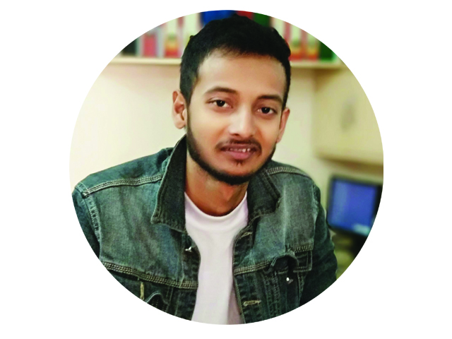**NIKHIL BHAGAT**

**ADDRESS:**

**Province - 01, Biratnagar, programmer@nikhilbhagat.com.np**

**Hathkhola, +977-9814344114.**

**Near Singhya Bridge. https://github.com/NikeGunn/**

**Objective**

**A talented Web Developer with passion for tailored solutions, to contribute in creating extraordinary experience for your organization’s technical audience.**

**Educational Qualification**

**MAHENDRA MORANG AADARSHA MULTIPLE CAMPUS**

**Bachelor Of Computer Application 2021**

(Second Semister).

**MERRYLAND COLLEGE.**

Senior secondary school certificate  **2013**

**Courses and Training**

**Full Stack web-Developer 2016**

**Proficient In:**

* **HTML5**
* **CSS3**
* **BOOSTRAP**
* **CSSGRID**
* **JAVASCRIPT**
* **REACTJS**
* **Nodejs**
* **MySql**
* **ExpressJs**
* **Dart**

**Core Skills**

* IT Skills: Microsoft Office : Word, Excel, PowerPoint
* Communication skills
* Tact.

**Interest**: Reading, Research, Meeting People**.**

**REFERENCES**

* Mr. Raman Subedi

Hathkhla,Biratnagar

+97-9824370085

Province 01

* Mr. Ayush Thapaliya

Ratuwamai

+977-9816319497